

JOMO KENYATTA UNIVERSITY OF AGRICULTURE AND TECHNOLOGY

SCHOOL OF ELECTRICAL, INFORMATION AND ELECTRONIC ENGINEERING

DEPARTMENT OF ELECTRONIC AND COMPUTER ENGINEERING

OBJECT ORIENTED PROGRAMMING PROJECT

EEC 2212

NAME: SHANTAL SIFA NZAVAI

REG NO: ENE212-0058/2024

DATE: 19/05/2026

SMART LECTURE ROOM AND LABORATORY MANAGEMENT SYSTEM

1. INTRODUCTION
The Smart Lecture Room and Laboratory Management System is a console-based software application developed using the C++ programming language and Object-Oriented Programming (OOP) principles. The system is designed to help institutions manage lecture halls, laboratories, room booking, and timetable scheduling efficiently.
In many universities and colleges, students and lecturers often face challenges locating lecture rooms and laboratories due to timetable changes, room reallocations, and poor room management. These challenges lead to lateness, confusion, overcrowding, and inefficient use of institutional facilities.
The proposed system provides an organized and computerized approach for managing lecture rooms and laboratories. The system allows users to search for rooms, display available rooms, manage timetable schedules, and detect timetable conflicts.
This makes the system more realistic, flexible, and scalable for real institutional environments.

2. BACKGROUND OF THE STUDY
As institutions continue to grow, managing lecture halls and laboratories manually becomes increasingly difficult. Most institutions still rely on printed timetables, noticeboards, and verbal communication for room allocation and scheduling.
Some common challenges experienced include:
- Students moving from one building to another searching for classes
- Timetable conflicts
- Double booking of rooms
- Difficulty identifying available rooms
- Poor laboratory management
- Delays in lectures due to room confusion
These problems reduce efficiency within institutions and waste time for both students and lecturers.The Smart Lecture Room and Laboratory Management System was therefore developed to improve room allocation, laboratory management, and timetable scheduling processes.

3. OBJECTIVES

Main Objective
To design and develop a Smart Lecture Room and Laboratory Management System using C++ and Object-Oriented Programming principles.

Specific Objectives
The project aims to:
- Store room and laboratory information electronically
- Allow users to search for lecture rooms easily
- Display available and occupied rooms
- Improve laboratory management
- Reduce timetable conflicts
- Support room booking operations
- Improve timetable scheduling
- Demonstrate practical implementation of Object-Oriented Programming concepts

4. SCOPE OF THE SYSTEM
The system focuses on managing:
- Lecture halls
- Laboratories
- Seminar rooms
- Tutorial rooms
The system supports:
- Room searching
- Room booking
- Timetable management
- Conflict detection
- Room allocation
- Laboratory management

5. FUNCTIONAL REQUIREMENTS
The system should be able to:
- Add lecture halls
- Add laboratories
- Display all rooms
- Search rooms by ID
- Display available rooms
- Book rooms
- Add classes to timetable
- Update timetable schedules
- Cancel classes
- Detect timetable conflicts
- Delete room records

6.NON-FUNCTIONAL REQUIREMENTS
The system should:
- Be user-friendly
- Be efficient and reliable
- Have fast response time
- Be scalable
- Be easy to maintain
- Reduce scheduling errors

7. SYSTEM ARCHITECTURE

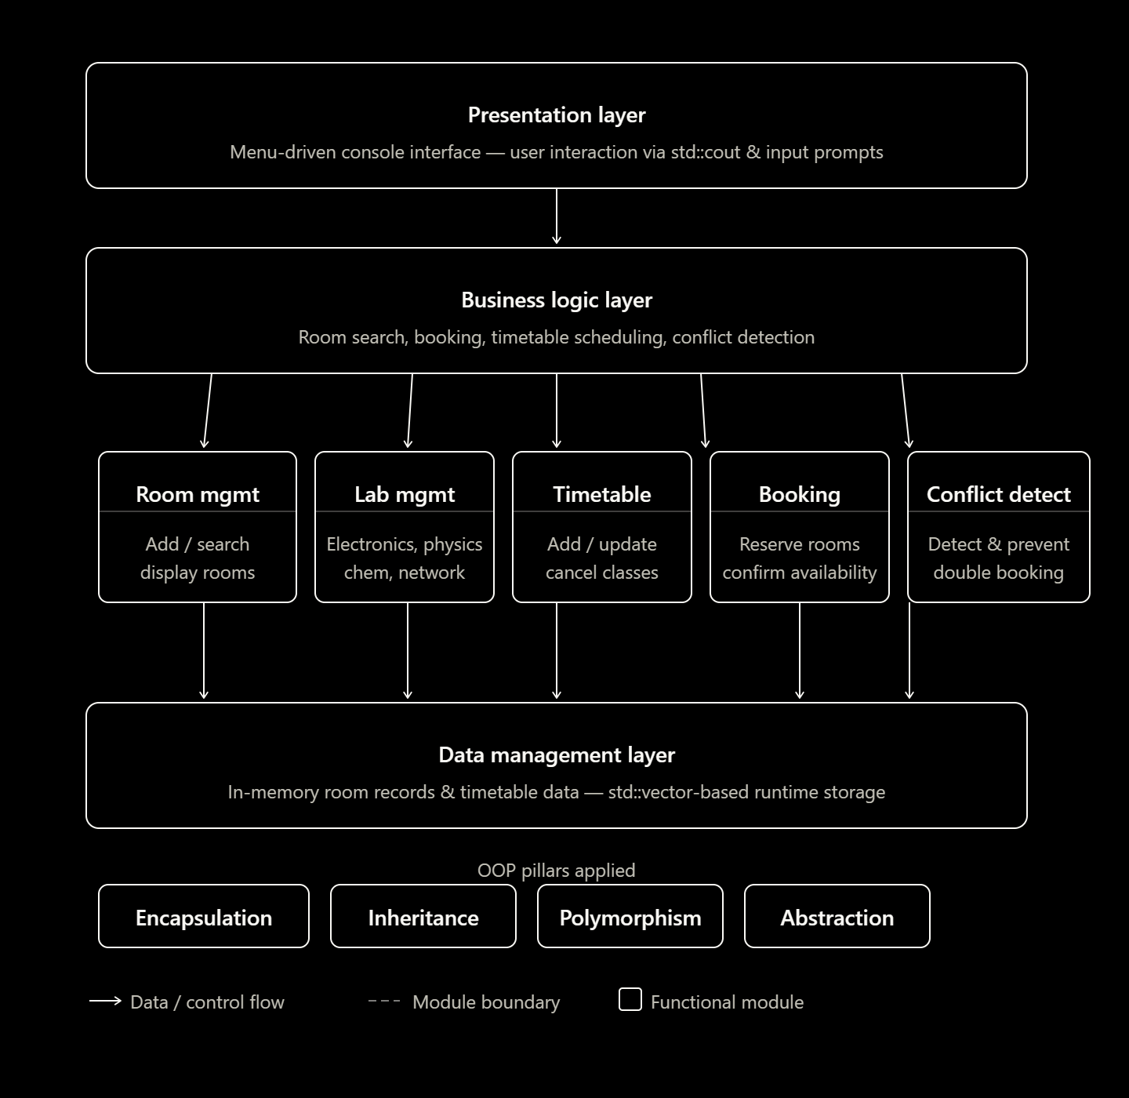

8.BLOCK DIAGRAM

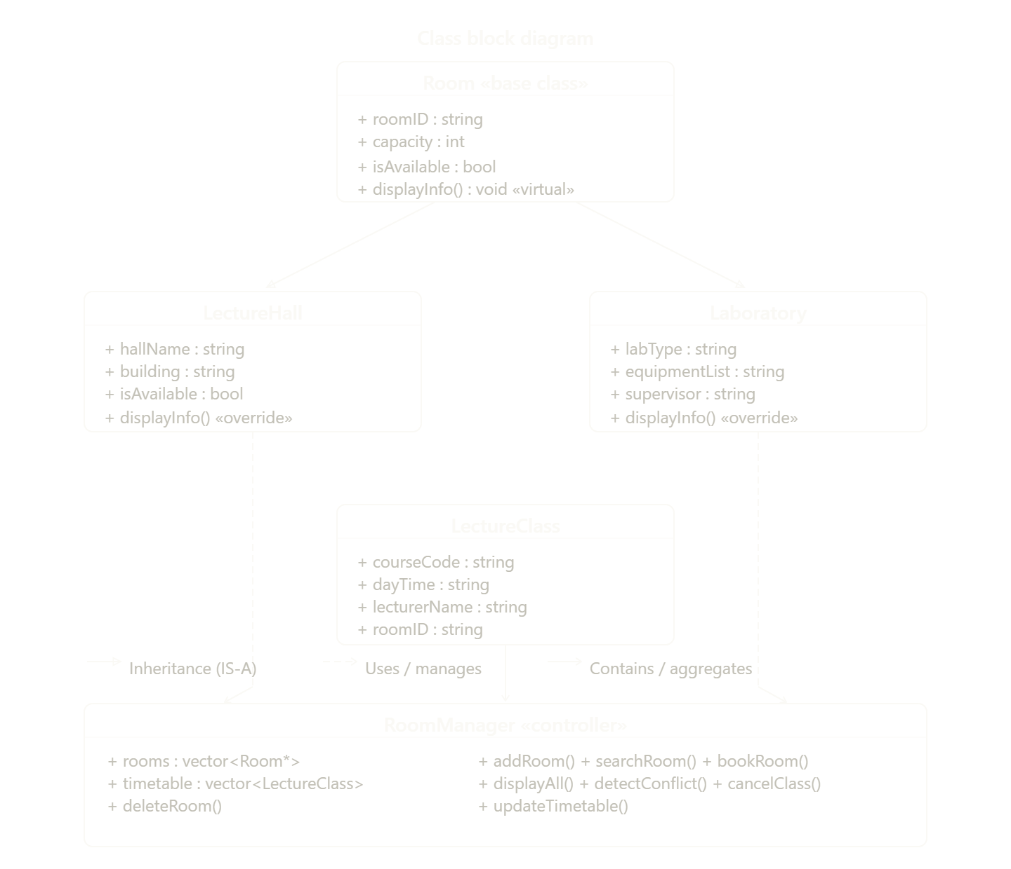

9. OOP CONCEPTS APPLIED
The project successfully demonstrates the four pillars of Object-Oriented Programming.

Encapsulation
Room and timetable information are protected within classes and accessed through methods.

Inheritance
Lecture halls and laboratories inherit common properties from a parent room structure.

Polymorphism
Different room categories display information differently using overridden methods.

Abstraction
Users interact with simple menus while complex internal operations remain hidden.

10. CLASSES AND RESPONSIBILITIES
Class | Responsibility
Room | Stores general room information
LectureHall | Represents lecture halls
Laboratory | Represents institutional laboratories
LectureClass | Handles timetable details
RoomManager | Handles room and timetable operations

11. SYSTEM WORKFLOW

Room Search Process
- User enters room details or room ID
- System checks stored room records
- Matching room information is displayed

Room Booking Process
- User selects a room
- System checks room availability
- Timetable conflict detection is performed
- Booking is confirmed if no conflict exists

Timetable Management Process
- Administrator enters class details
- System validates timetable information
- Timetable is updated successfully

12.TESTING AND VALIDATION
Test case | Input | Expected Output | Status
Add Lecture Hall | Room ID, Name, Capacity | Lecture hall added successfully | Passed
Add Laboratory | Lab details entered | Laboratory added successfully | Passed
Search Existing Room | Valid Room ID | Room information displayed | Passed
Search Invalid Room | Invalid Room ID | “Room Not Found” message | Passed
Display Available Rooms | Request availability | Available rooms displayed | Passed
Book Available Room | Valid room and time | Booking successful | Passed
Book Occupied Room | Occupied room | Conflict warning displayed | Passed
Add Timetable Class | Valid class details | Class added successfully | Passed
Cancel Class | Existing class | Class cancelled successfully | Passed
Delete Room | Existing room ID | Room deleted successfully | Passed

13.EXPECTED OUTPUT.
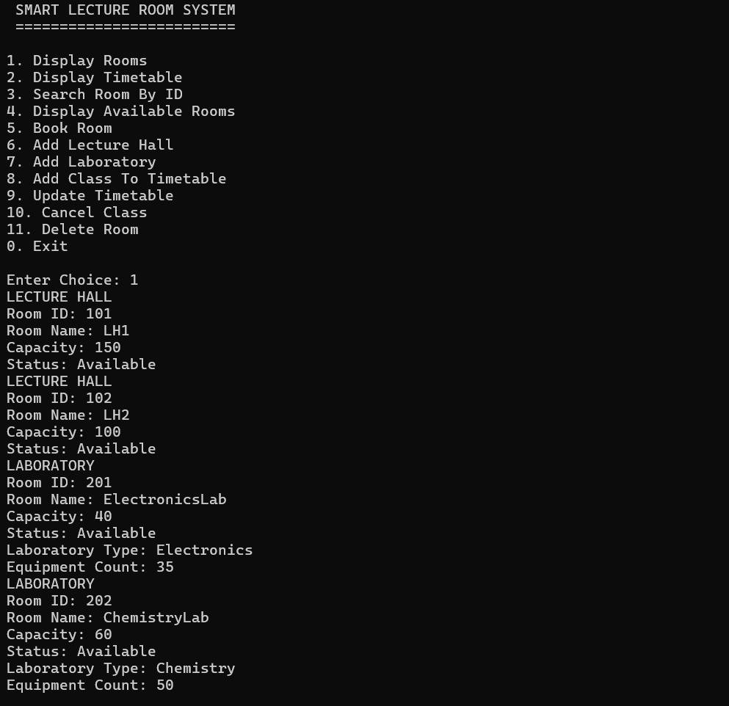 | 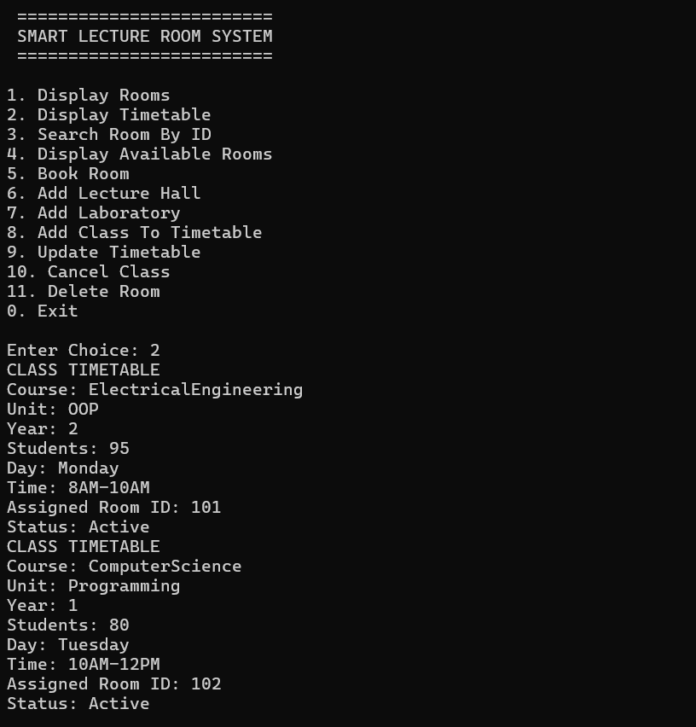 | 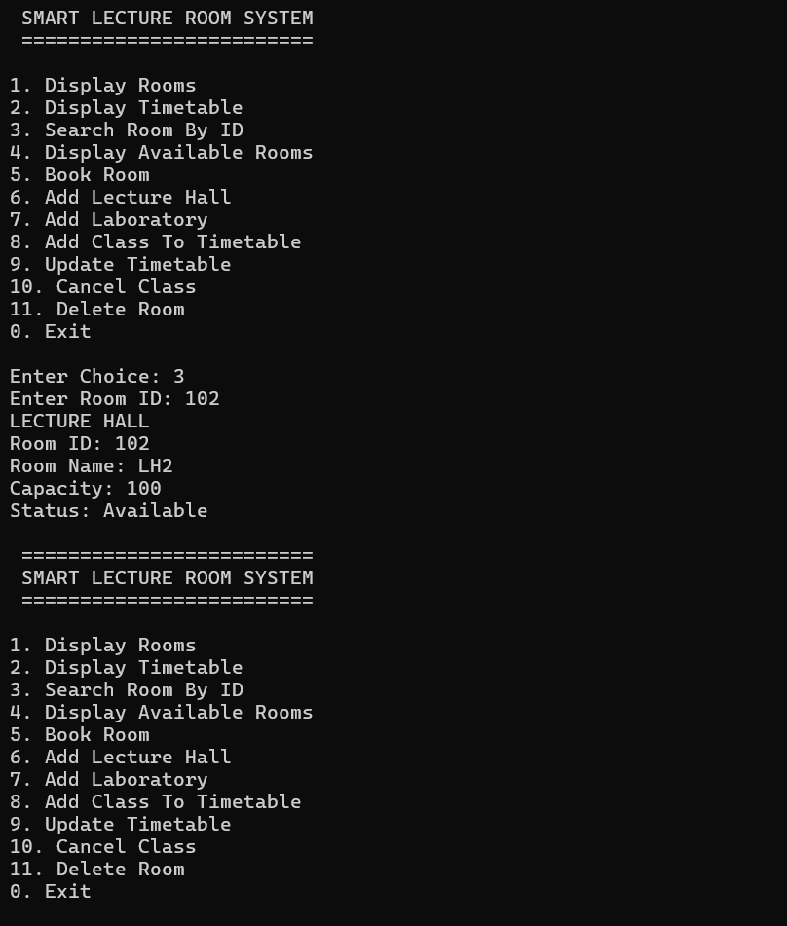
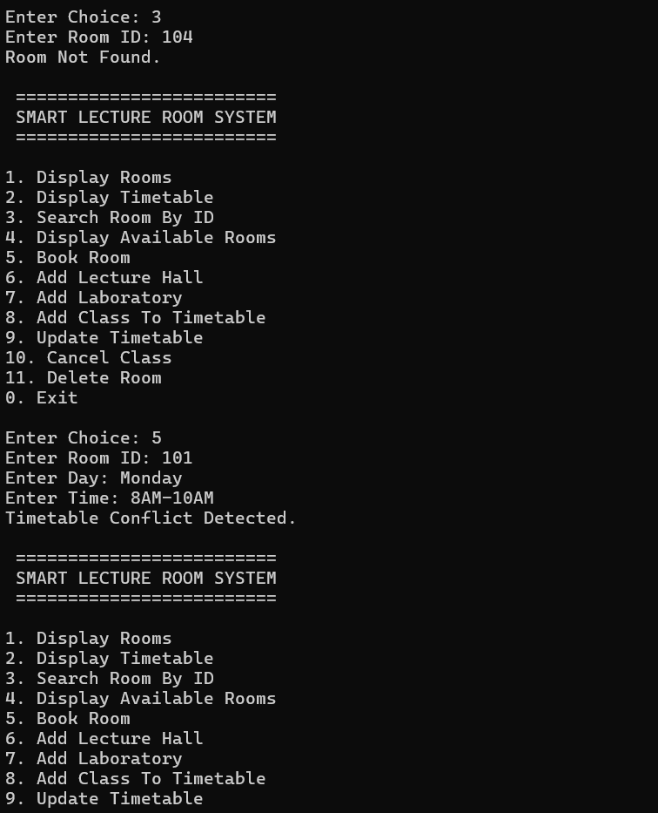 | 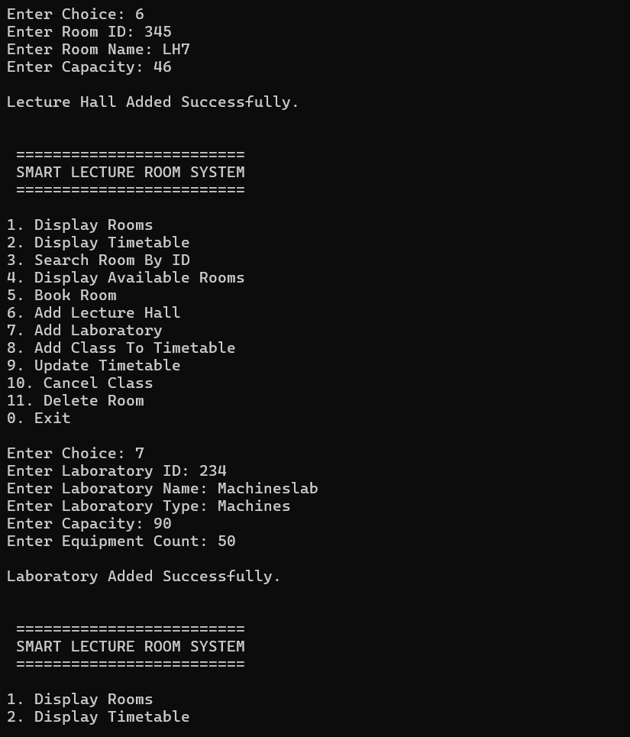 | 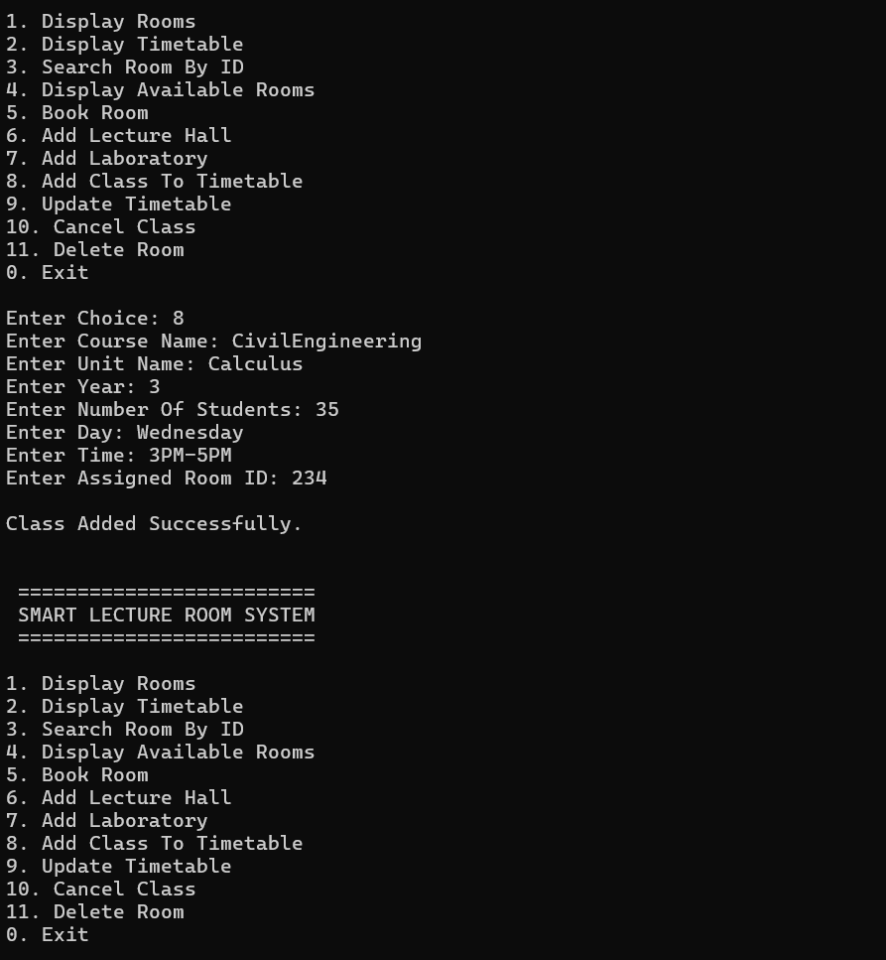
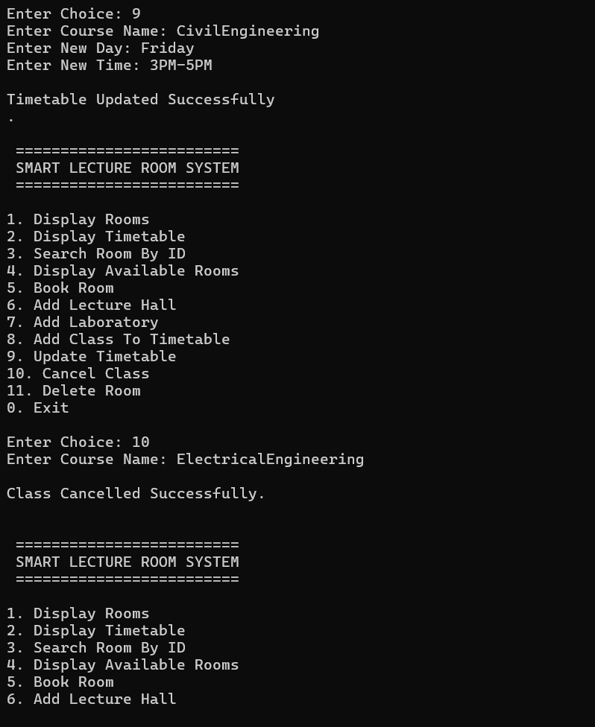 | 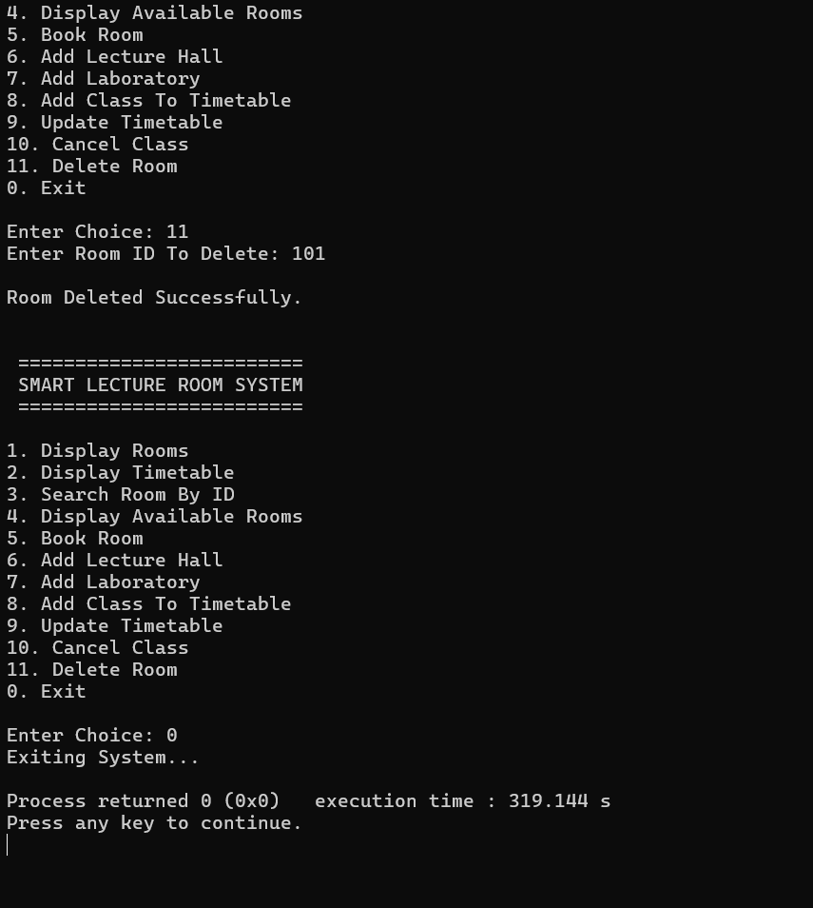

14. FUTURE IMPROVEMENTS
Future improvements may include:
- Database integration
- Mobile application support
- Online room booking
- Automatic timetable generation
- User authentication
- Cloud-based storage
- Smart classroom integration
- Notification systems

15. CONCLUSION
The Smart Lecture Room and Laboratory Management System provides a practical solution to challenges experienced in lecture room allocation, timetable management, and laboratory management within institutions.
The system improves room allocation efficiency, reduces timetable conflicts, and enhances organization within educational institutions. The project also demonstrates successful implementation of Object-Oriented Programming concepts using C++.

